CR042

Noddle Reference Number (CDP)

**Contents**

1 Introduction 3

2 High Level Design 4

2.1.1 Dispute Case Home / Data Services Case Home (Flows) 4

2.1.2 Stash Data / API 5

3 Impact 6

3.1 Delivery Schedule 6

3.2 Resource 6

3.3 Infrastructure 6

3.4 Licensing 6

3.5 Service Costs 6

**Amendment History**

|  |  |  |  |
| --- | --- | --- | --- |
| **Revision** | **Date Issued** | **Author** | **Reason for Change / Description** |
| V1.0 | 22/03/2019 | Kevin Wing | Initial version |
|  |  |  |  |
|  |  |  |  |
|  |  |  |  |
|  |  |  |  |

# Introduction

During the testing of the CRs the UAT team have identified a missing piece of information to facilitate their business processes. The CDP team require access to the Noddle Reference number that is passed in the dispute from Noddle into Numero. The requirement is to display this on the dispute case.

# High Level Design

### Dispute Case Home / Data Services Case Home (Flows)

The Noddle Reference Number will need to be returned in the API and surfaced on the Dispute Case. Specifically, it will be displayed within each respective Dispute Type specific container as shown below:

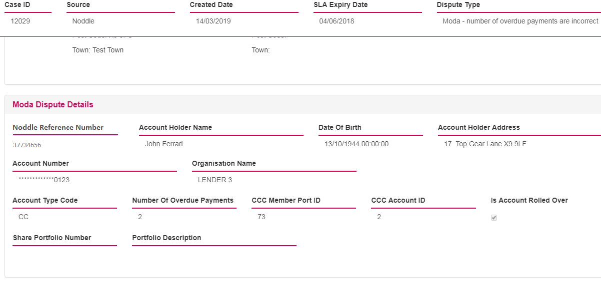

### Stash Data / API

The new field currently exists within the Dispute Case stash type within the Disputes array:

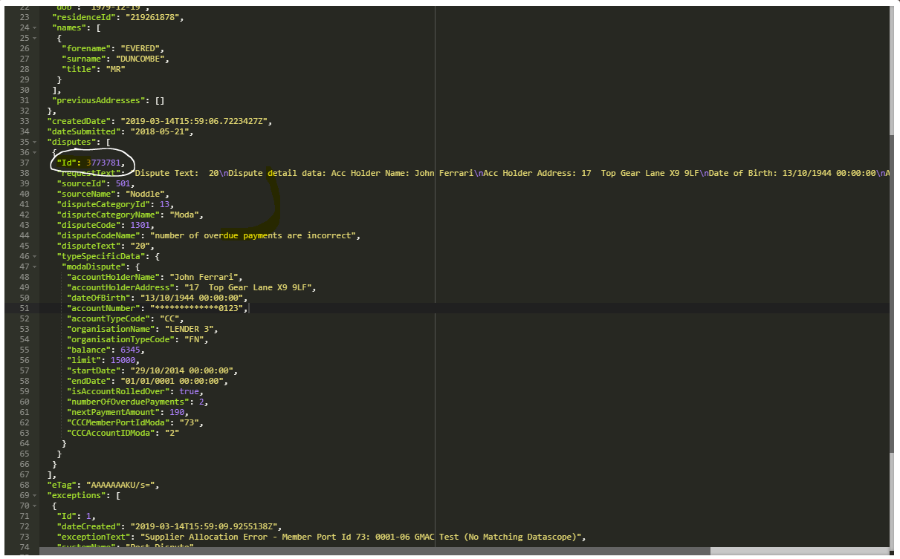

# Impact

## Delivery Schedule

This is not a major change and could potentially be delivered in readiness for Phase 1 go-live.

## Resource

|  |  |
| --- | --- |
| Description of work | Effort (days) |
| Build – Flows  Build – Connect API | 0.5  0.5 |
| **Total Effort** | **1** |

## Infrastructure

There are no impacts on the proposed solution architecture because of this change.

## Licensing

There are no licensing implications related to this change.

## Service Costs

There are no service costs related to this change.